In order to have the same database, please import this database:

CREATE DATABASE IF NOT EXISTS `P4_queries01` DEFAULT CHARACTER SET utf8mb4 COLLATE utf8mb4_general_ci;

USE `P4_queries01`;

DROP TABLE IF EXISTS `DEPARTMENTS`;

CREATE TABLE `DEPARTMENTS` (

`num` int(11) NOT NULL,

`name` varchar(30) NOT NULL,

`town_code` varchar(3) DEFAULT NULL

) ENGINE=InnoDB DEFAULT CHARSET=latin1;

INSERT INTO `DEPARTMENTS` (`num`, `name`, `town_code`) VALUES

(10, 'ACCOUNTING', 'SVQ'),

(20, 'RESEARCH', 'MAD'),

(30, 'SALES', 'BCN'),

(40, 'PRODUCTION', 'BIO');

DROP TABLE IF EXISTS `EMPLOYEES`;

CREATE TABLE `EMPLOYEES` (

`num` int(11) NOT NULL,

`surname` varchar(50) NOT NULL,

`name` varchar(50) NOT NULL,

`manager` int(11) DEFAULT NULL,

`start_date` date DEFAULT NULL,

`salary` int(11) DEFAULT NULL,

`commission` int(11) DEFAULT NULL,

`dept_num` int(11) DEFAULT NULL,

`occu_code` varchar(3) DEFAULT NULL

) ENGINE=InnoDB DEFAULT CHARSET=latin1;

INSERT INTO `EMPLOYEES` (`num`, `surname`, `name`, `manager`, `start_date`, `salary`, `commission`, `dept_num`, `occu_code`) VALUES

(800, 'BANDERAS', 'ANTONIO', NULL, '1991-01-09', 2885, NULL, 20, NULL),

(7369, 'SÁNCHEZ', 'SERGIO', 7902, '1990-12-17', 1040, NULL, NULL, NULL),

(7499, 'ARROYO', 'MARTA', 7698, '1990-02-20', 1500, 390, 30, 'SAL'),

(7521, 'AGUILO', 'JOSEP', 7698, '1991-02-22', 1625, 650, 30, 'SAL'),

(7566, 'AROCA', 'JUDIT', 7839, '1991-04-02', 2900, NULL, 20, 'MAN'),

(7654, 'MARTÍN', 'MONICA', 7698, '1991-09-29', 1600, 1020, 30, 'SAL'),

(7698, 'AMER', 'BARTOLOME', 7839, '1991-05-01', 3005, NULL, 30, NULL),

(7782, 'COLOM', 'ENRIQUE', 7839, '1991-06-09', 2885, NULL, 10, 'MAN'),

(7788, 'GIL', 'JAVIER', 7566, '1991-11-09', 3000, NULL, 20, 'ANA'),

(7844, 'TOVAR', 'LUIS', 7698, '1991-09-08', 1350, 0, 30, 'SAL'),

(7876, 'ALONSO', 'FERNANDO', 7788, '1991-09-23', 1430, NULL, 20, 'EMP'),

(7900, 'JIMENO', 'XAVIER', 7698, '1991-12-03', 1335, NULL, 30, 'EMP'),

(7902, 'FERNÁNDEZ', 'ANA', 7566, '1991-12-03', 3000, NULL, NULL, 'ANA'),

(7934, 'MUÑOZ', 'ANTONIA', 7782, '1992-01-23', 1690, NULL, 10, 'EMP'),

(8001, 'RUIZ', 'FERNANDA', 7839, '1992-06-10', 2885, NULL, 20, 'MAN');

DROP TABLE IF EXISTS `OCCUPATIONS`;

CREATE TABLE `OCCUPATIONS` (

`code` varchar(3) NOT NULL,

`name` varchar(30) NOT NULL

) ENGINE=InnoDB DEFAULT CHARSET=latin1;

INSERT INTO `OCCUPATIONS` (`code`, `name`) VALUES

('ANA', 'ANALYST'),

('EMP', 'EMPLOYEE'),

('MAN', 'MANAGER'),

('PRE', 'PRESIDENT'),

('SAL', 'SALESMAN');

DROP TABLE IF EXISTS `TOWNS`;

CREATE TABLE `TOWNS` (

`code` varchar(3) NOT NULL,

`name` varchar(30) NOT NULL

) ENGINE=InnoDB DEFAULT CHARSET=latin1;

INSERT INTO `TOWNS` (`code`, `name`) VALUES

('BCN', 'BARCELONA'),

('BIO', 'BILBAO'),

('MAD', 'MADRID'),

('SVQ', 'SEVILLA');

ALTER TABLE `DEPARTMENTS`

ADD PRIMARY KEY (`num`),

ADD KEY `town_code` (`town_code`);

ALTER TABLE `EMPLOYEES`

ADD PRIMARY KEY (`num`),

ADD KEY `dept_num` (`dept_num`),

ADD KEY `occu_code` (`occu_code`);

ALTER TABLE `OCCUPATIONS`

ADD PRIMARY KEY (`code`);

ALTER TABLE `TOWNS`

ADD PRIMARY KEY (`code`);

ALTER TABLE `DEPARTMENTS`

ADD CONSTRAINT `DEPARTMENTS_ibfk_1` FOREIGN KEY (`town_code`) REFERENCES `TOWNS` (`code`);

ALTER TABLE `EMPLOYEES`

ADD CONSTRAINT `EMPLOYEES_ibfk_1` FOREIGN KEY (`dept_num`) REFERENCES `DEPARTMENTS` (`num`),

ADD CONSTRAINT `EMPLOYEES_ibfk_2` FOREIGN KEY (`occu_code`) REFERENCES `OCCUPATIONS` (`code`);

COMMIT;

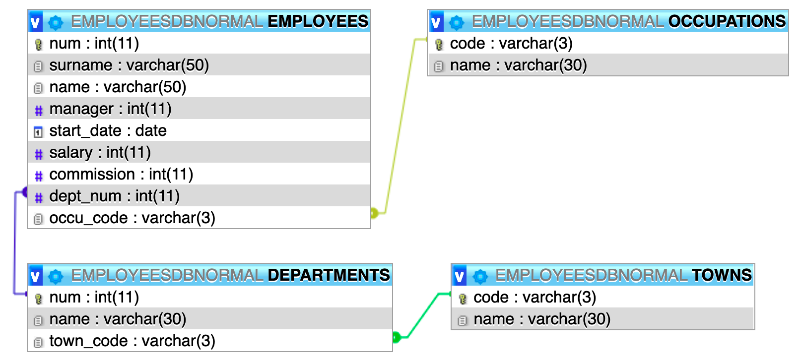

|  |  |
| --- | --- |
|  | |
|  | |
|  |  |

**1.** Show the full name of employees, salary and occupation name whose salary is not between 1100 and 2000. Sort the results by full name. Make four versions:

* Using an explicit inner join,
* using an implicit inner join,
* using a left outer join,
* and using a right outer join.

|  |  |  |  |
| --- | --- | --- | --- |
| explicit inner join | implicit inner join | left outer join | right outer join |
|  |  |  |  |

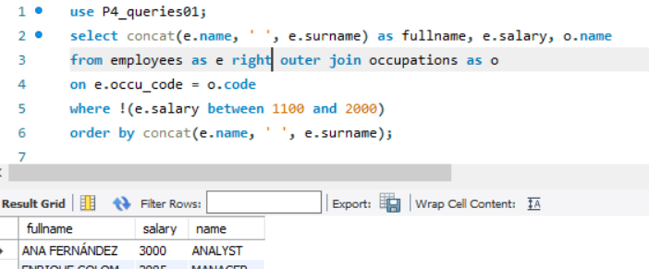

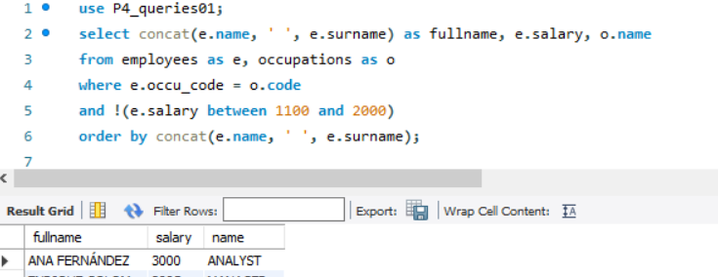

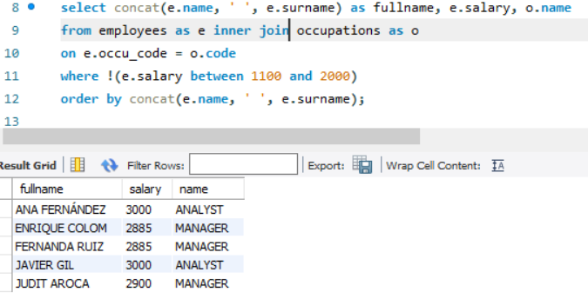

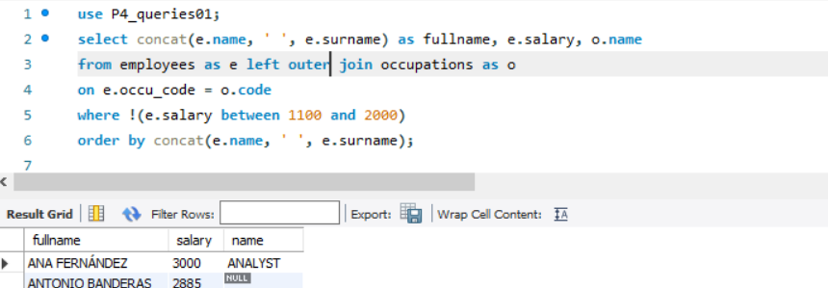

**2.** Select the surname and occupation of the employees of department number 20 (show occupation name instead occupation code). Make four versions:

* Using an explicit inner join,
* using an implicit inner join,
* using a left outer join,
* and using a right outer join.

|  |  |  |  |
| --- | --- | --- | --- |
| explicit inner join | implicit inner join | left outer join | right outer join |
|  |  |  |  |

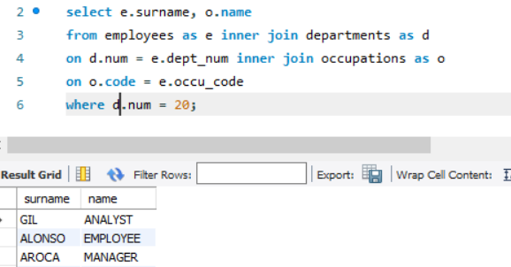

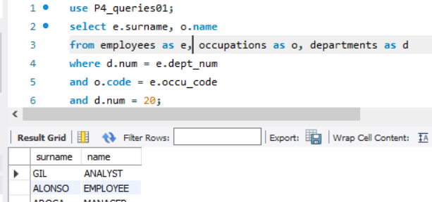

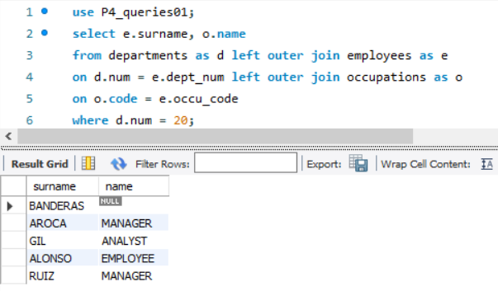

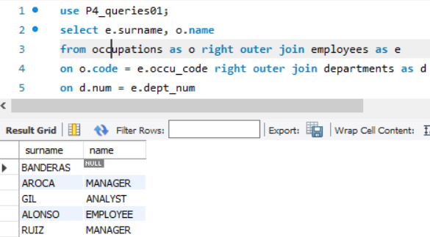

**3.** Show employee full name of the employees with no occupation and no department (sorted by full name).

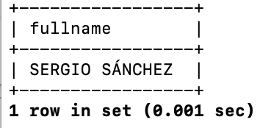

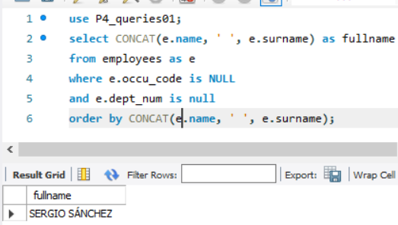

**El comando FULL OUTER JOIN no me lo reconoce en sql**

**4.** Show employee full name of the employees with no occupation or no department (sorted by full name).

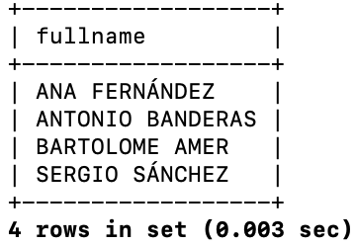

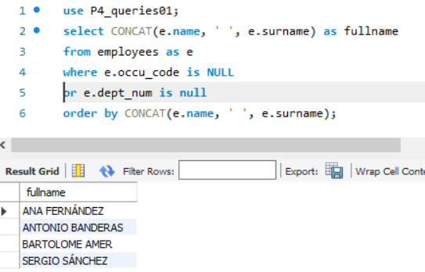

**5.** Show the full names of the employees amb occupation name whose occupation is neither "MANAGER" nor "EMPLOYEE" (=”occupation is not manager and is not employee”) and also have a salary higher than 2000.

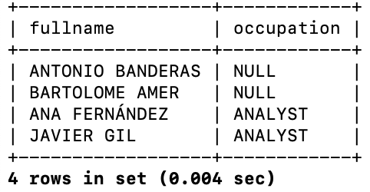

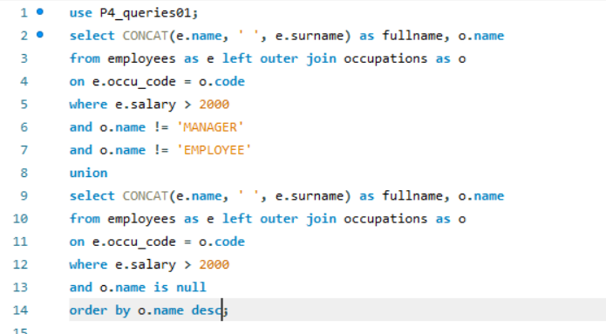

**6.** Show all the data of all the employees (show department name instead department code, occupation name instead occupation code and manager surname instead manager num). Make two versions:

1. Using INNER JOIN.
2. Using LEFT OUTER JOIN.

|  |  |
| --- | --- |
| INNER JOIN | OUTER JOIN |
|  |  |

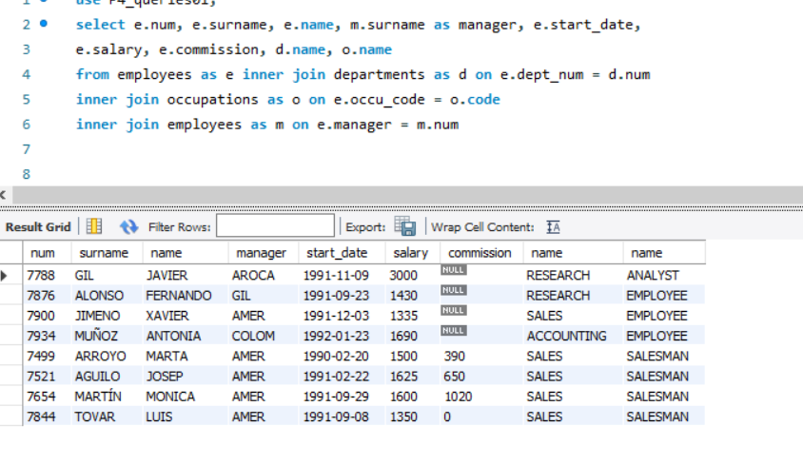

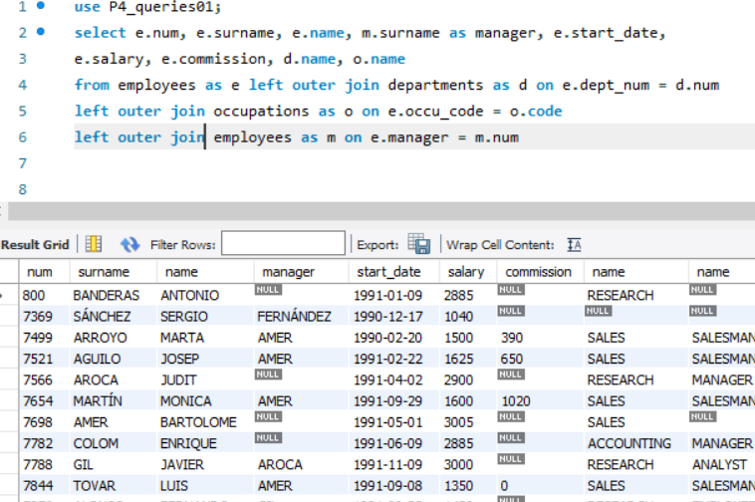

**7.** Show the data of the employees whose salary is greater than 2000 (show department name instead department code, occupation name instead occupation code and manager surname instead manager num). Make two versions:

1. Using INNER JOIN.
2. Using LEFT OUTER JOIN.

If you think about how to do a third version using RIGHT OUTER JOIN you’ll see that it’s not possible...

|  |  |
| --- | --- |
| INNER JOIN | OUTER JOIN |
|  |  |

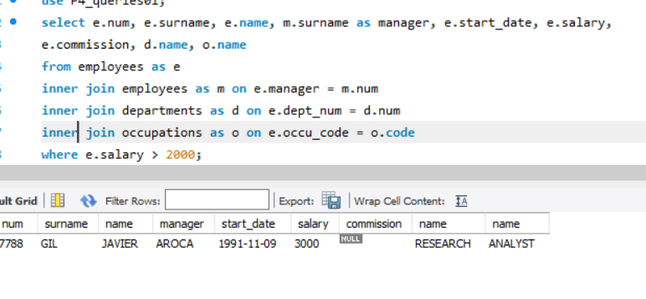

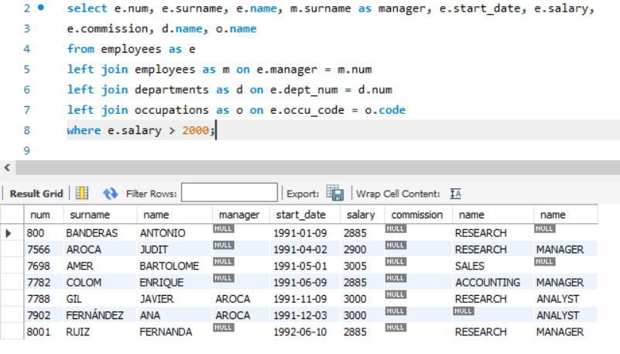

8.- Show number of employees per department considering employees with no department (clue: two queries with UNION).

